SAMSUNG
LCV 380D / 380S
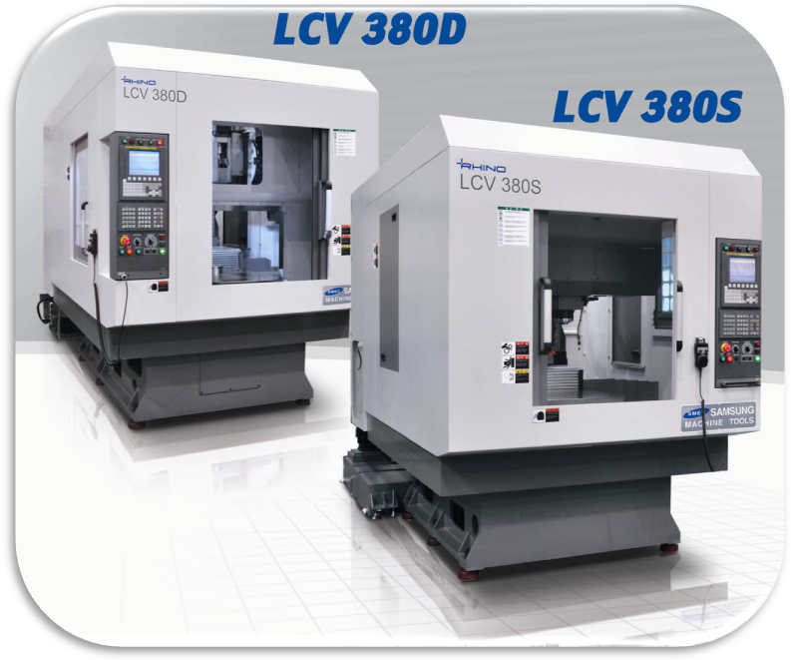VERTICAL MACHINING CENTER

MACHINE CONSTRUCTION / FEATURES (* ) : Spec. of LCV 380S
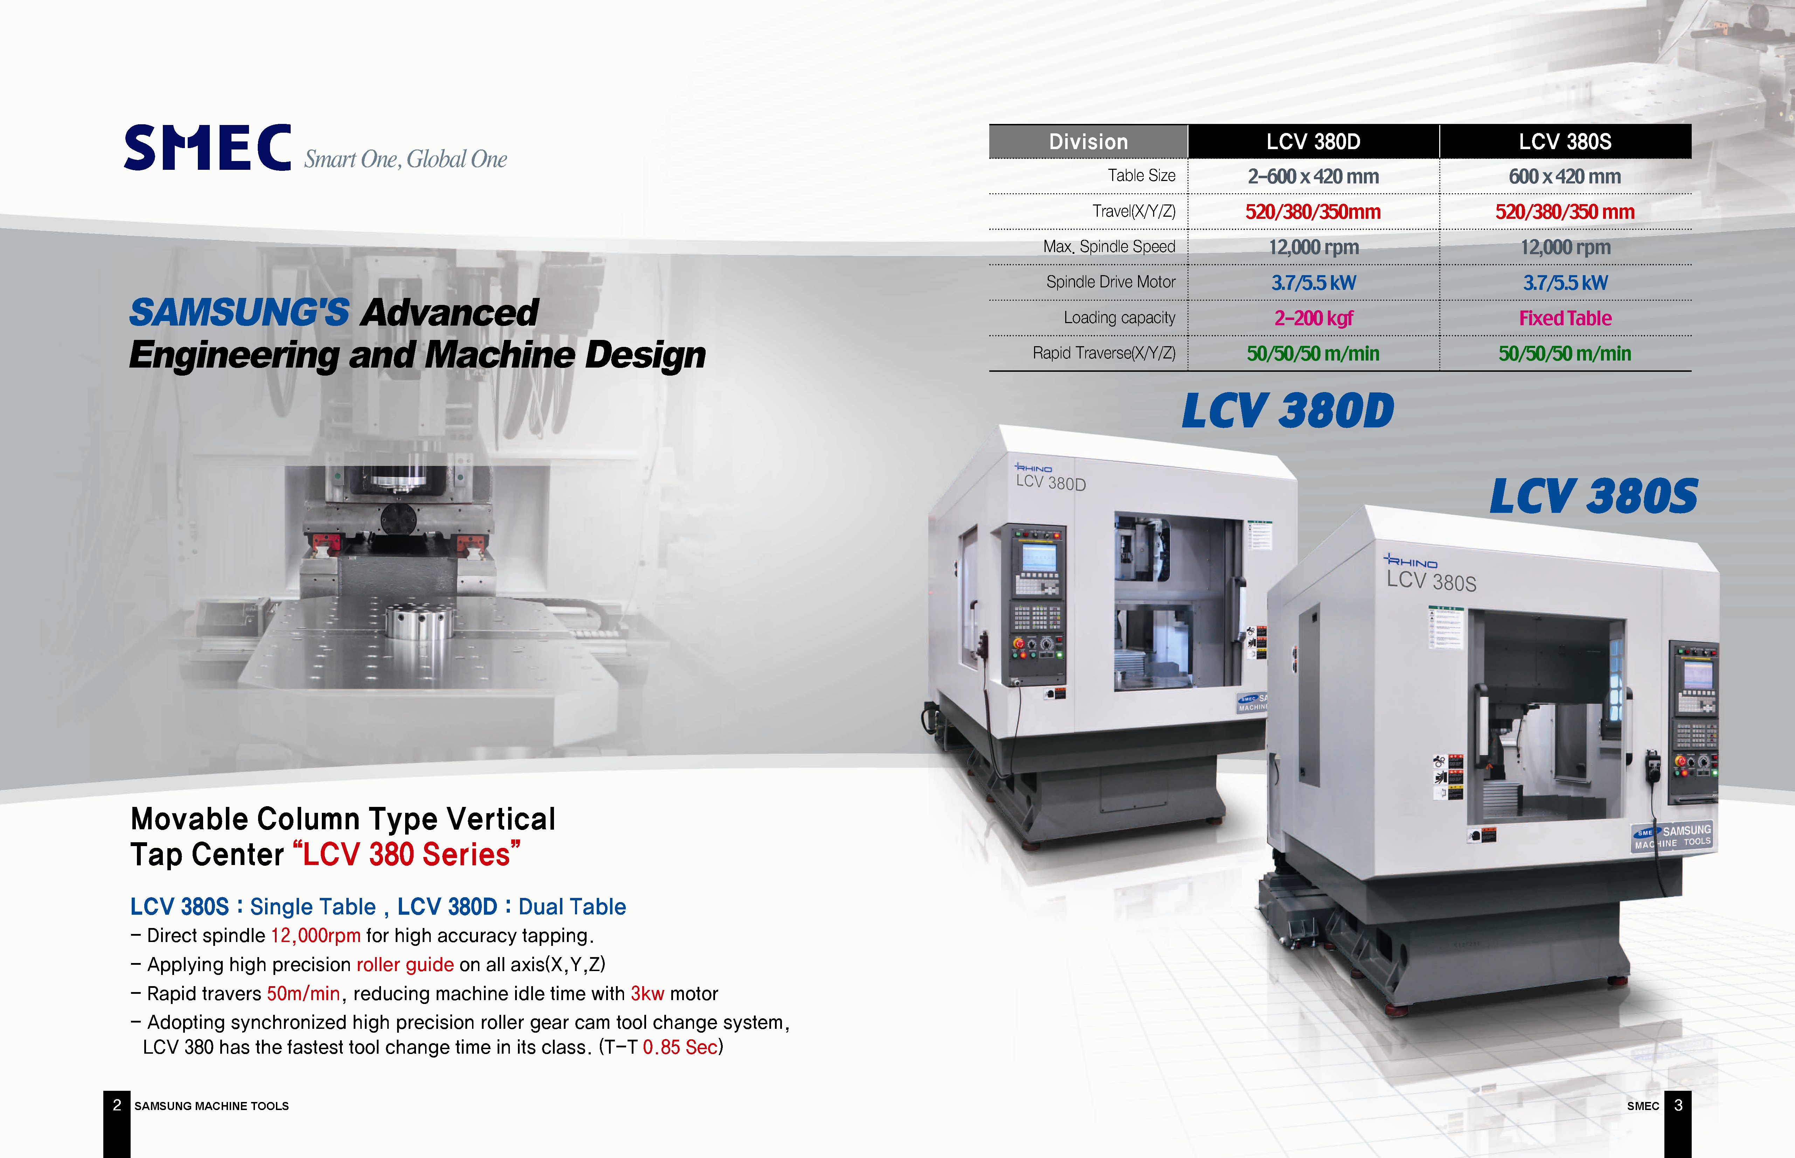
MOVABLE COLUMN TYPE VERTICAL
Tap Center “LCV 380 Series”

- Direct spindle 12,000rpm for high accuracy tapping.
- Applying high precision roller guide on all axis(X,Y,Z)
- Rapid travers 50m/min, reducing machine idle time with 3kw motor
- Adopting synchronized high precision roller gear cam tool change system, LCV 380 has the fastest tool change time in its class. (T-T0 .85 Sec)

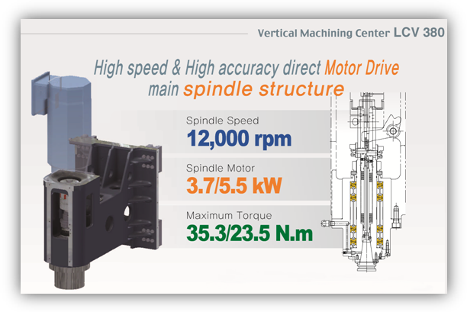SPINDLE HEAD

P4 class high precision angular contact ball bearings are used for high speed and ultra precision machining.
Direct drive main spindle for high speed-high accuracy synchrorized tapping.

Spindle Taper | Type | BT30
Spindle Drive Method | Type | Direct drive | Direct drive
Spindle speed | RPM | 12000 | 15000
Spindle Drive Motor |  | αiI 3/12000 | αiI 2/20000
Motor power(30min/Cont.) | kW | 5.5 / 3.7 | 3.7 / 2.2
Max. Torque  (S3 25%/Short/ Cont) | N.m | 35.3 / 23.5 | 11.8 / 6.9
Spindle Bearings | Front | 50BNR10STYNDBBELP4Y | 50BNR10HTYNDBBELP4Y
Spindle coupling | - | ROTEX GS-P 38(D44G6/D28H6) | ROTEX GS-P 38(D44H6/D22G6)
Spindle BRG lubrication | Type | Grease | Grease
Spindle cooling  (Oil Cooling) | - | Opt. | Opt.
Tool clamping Method | - | Disk spring(MUBEA)
Tool clamping/unclamping force | N | 3186 / 4569 | 2540 / 4421
Tool unclamping method | kgf/㎠ | Pneumatic 5 | Pneumatic 5

SPINDLE POWER-TORQUE DIAGRAM
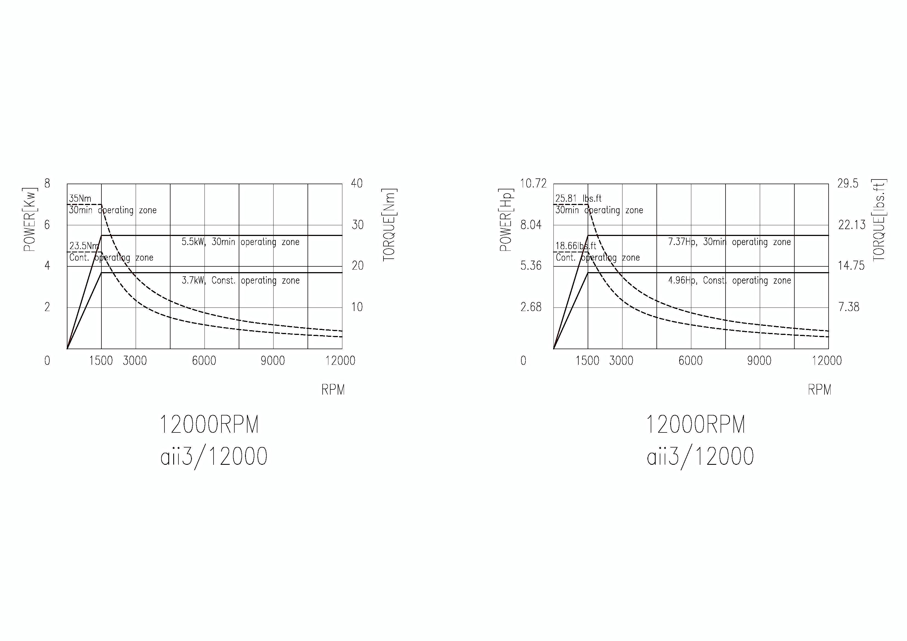
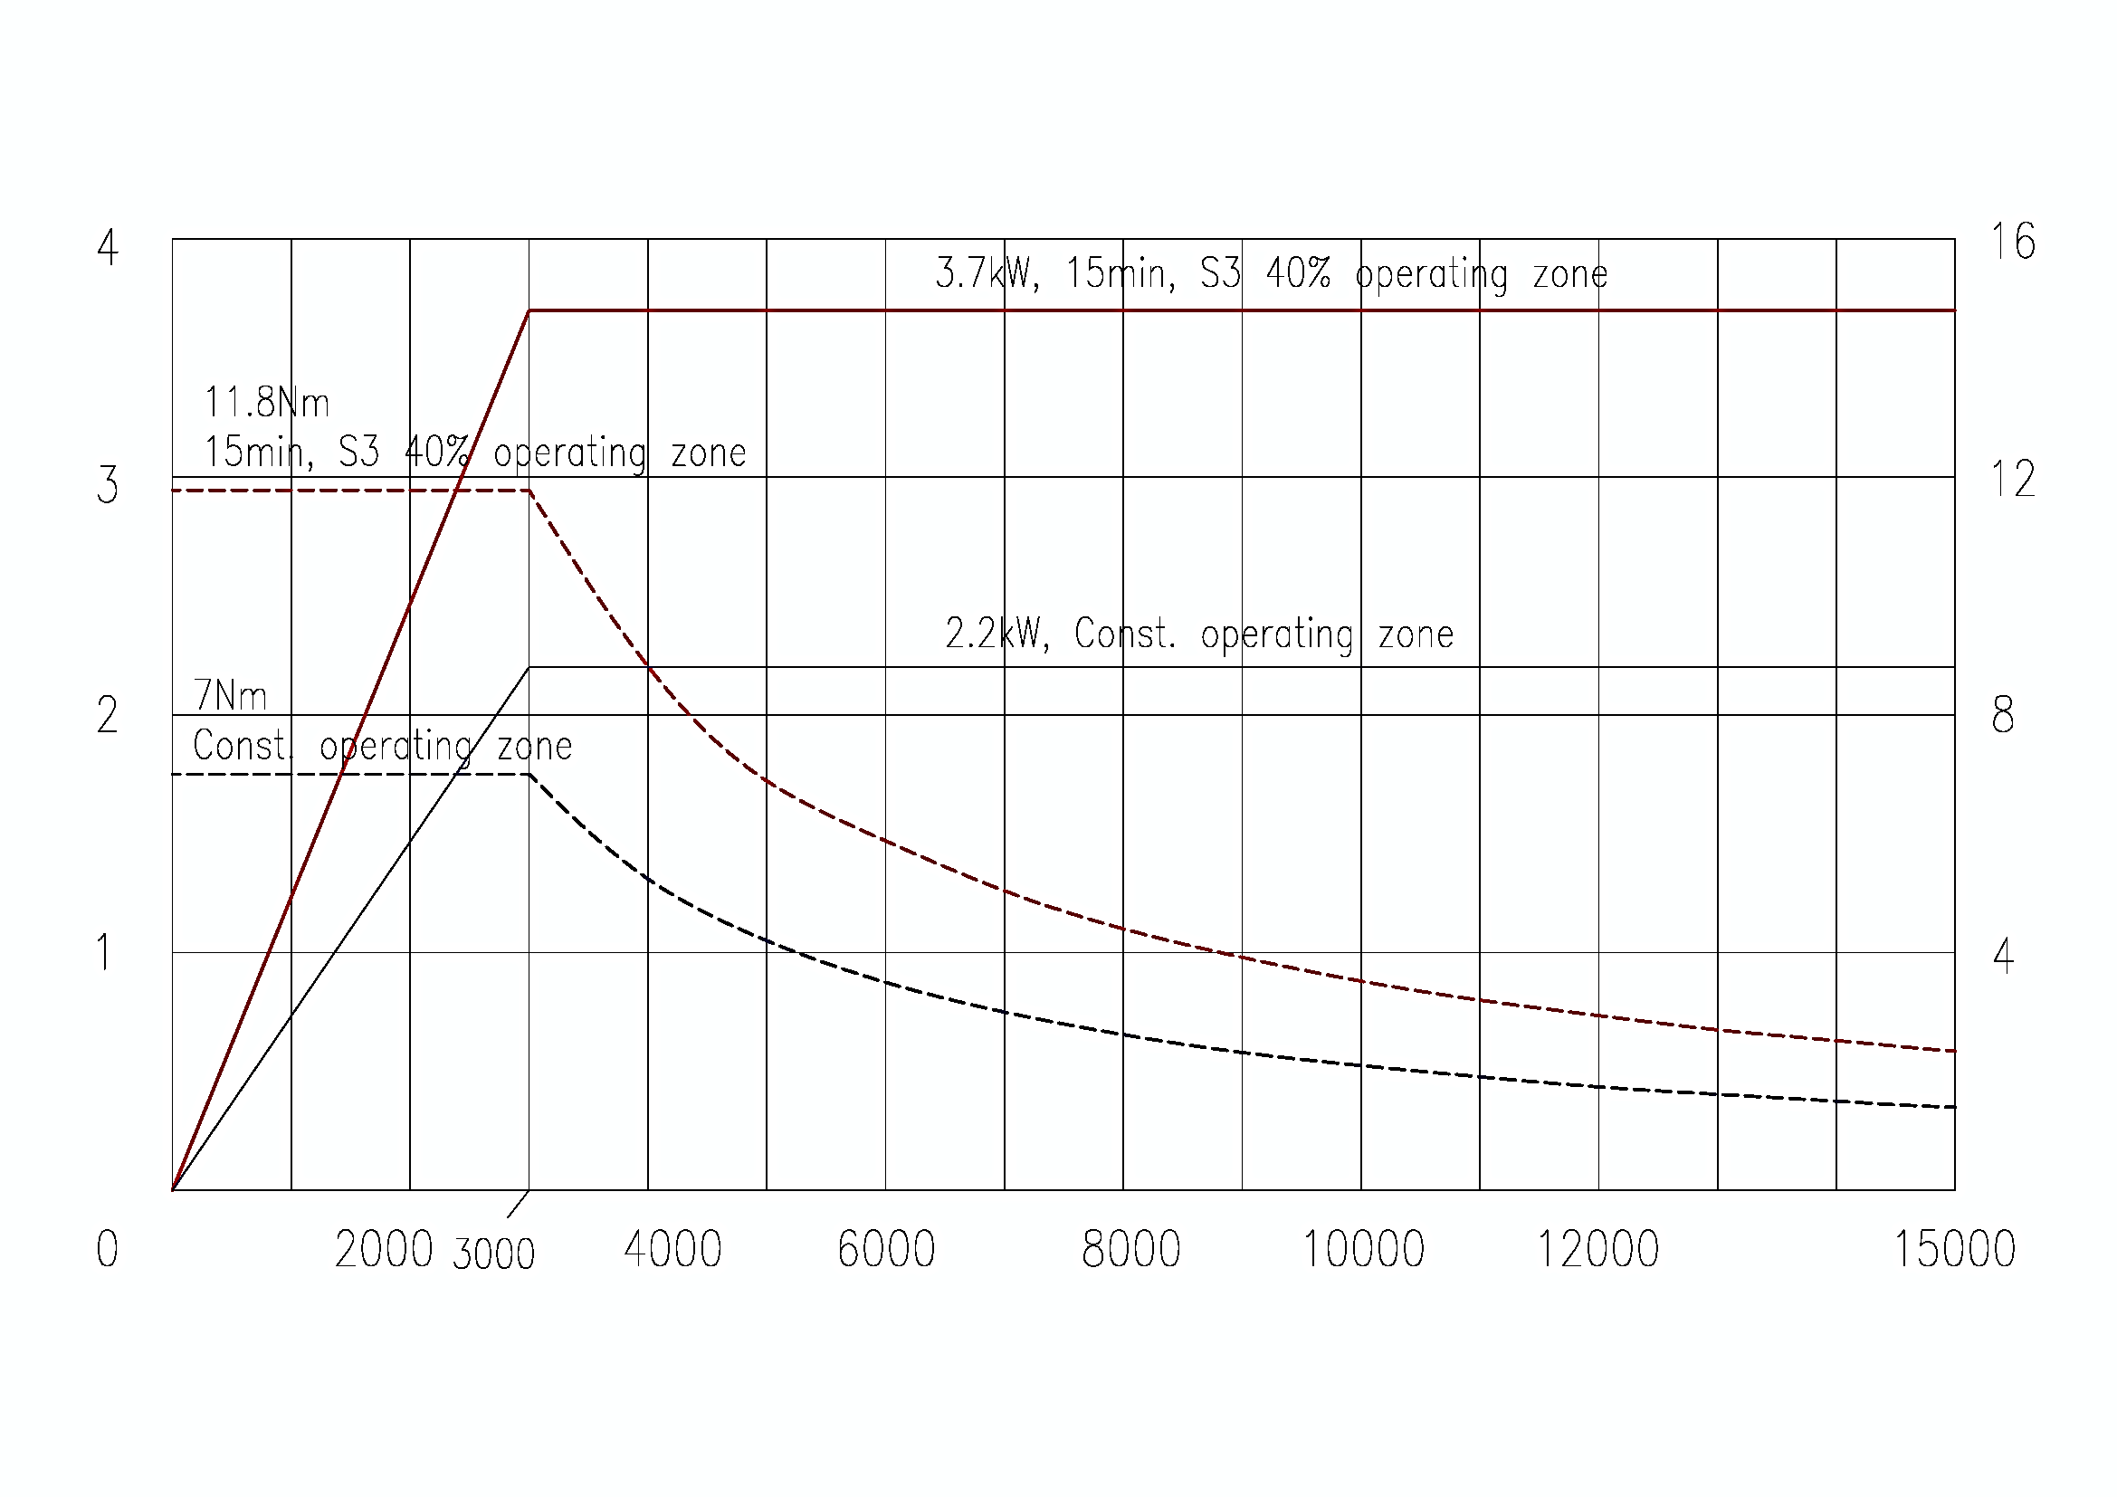
Power (kW)
Power (kW)
Torque (N.m)
RPM
RPM
Torque (N.m)
SERVO DRIVE SYSTEM

Guide plane of roller guide
High precision machining is achieved with the widest guide span in its class, low-centered box structure design, high-load roller guide.

Ball screws (X,Y,Z)
“Fixed and Supported” structure is applied on 32mm ball screws to minimize the change of ball screws in high speed machining and it provides extended life of ball screws also long lasting high precision.

3kw large capacity motor (X,Y,Z)
3kw motor is applied on all axis to achieve quiet and smooth machining and highly accurate cornering.

Items |  | X-axis | Y-axis | Z-axis
Travel  Rapid Traverse |  | 520mm  50m/min | 380mm  50m/min | 350mm  50m/min
Ball screw | Diameter x Lead | Ø32mm x 20mm | Ø32mm x 20mm | Ø32mm x 20mm
 | Spec.(HIWIN) | R32-20K5-FSC-714-880-0.018 | R32-20K5-FSC-557-720-0.018 | R32-20K5-FSC-525-713-0.018
 | Opt.(NSK) | W3207P-61PSS-C5Z20 | W3205P-84PSS-C5Z20 | W3205P-85PSS-C5Z20
Drive motor  (FANUC) | Servo Motor Type  Rated power | ß iS22/3000  3kW | ß iS22/3000  3kW | ß iS22B/3000  3kW
Feedback system | Absolute
Guide way | Slide Ways  Slide Way Span  Slide way Width  Safety Device | LM Guide  650mm  34mm  Soft OT, Mech. Stopper | LM Guide  370mm  34mm  Soft OT, Mech. Stopper | LM Guide  310mm  28mm  Soft OT, Mech. Stopper
 | Spec.(HIWIN) | RGW35HC2R1078ZBP II | RGW35CC2R958ZBP II | RGH30CA2R8082BP II
Accuracy | Positionig  Repeatability | ± 0.005  ± 0.002

AUTOMATIC TOOL CHANGER
/ MAGAZINE

- Tool Shank BT30
- Pull stud type MAS P30T-1(45° type)
- Maximum tool Diameter 60 mm
- Maximum tool Diameter 120 mm
[Adjacent empty]
- Maximum tool length 200 mm
- Maximum tool weight 3 kgf
- Tool changing method Double arm swing
- Tool selection method Memory random
- Tool changing time(T-T) 0.85 sec
- Magazine capacity 20 ea

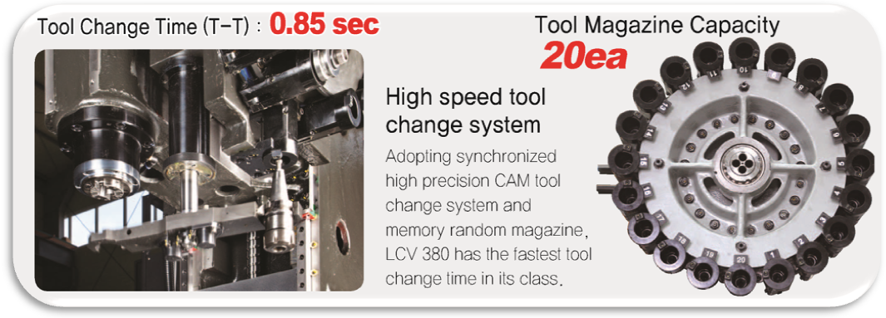
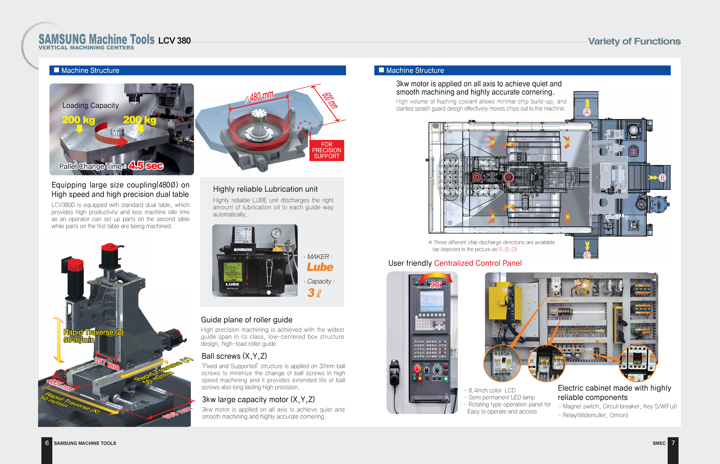TABLE
DUAL TABLE - LCV 380D / TABLE - LCV 380S

- Table size 2-600x520 (*600x420) mm
- Loading capacity 2x200 (*Fixed table) kgf
- Table surface Std.-Tap type
- LCV 380D 2x33-M16x90x90
- LCV 380S 35-M16x80x80
- Table surface - Opt. T-slot
Width 14
No. of slot 6(*3) ea
Distance between T-slot 110 mm
Distance from Floor to Table surface 950(*930) mm

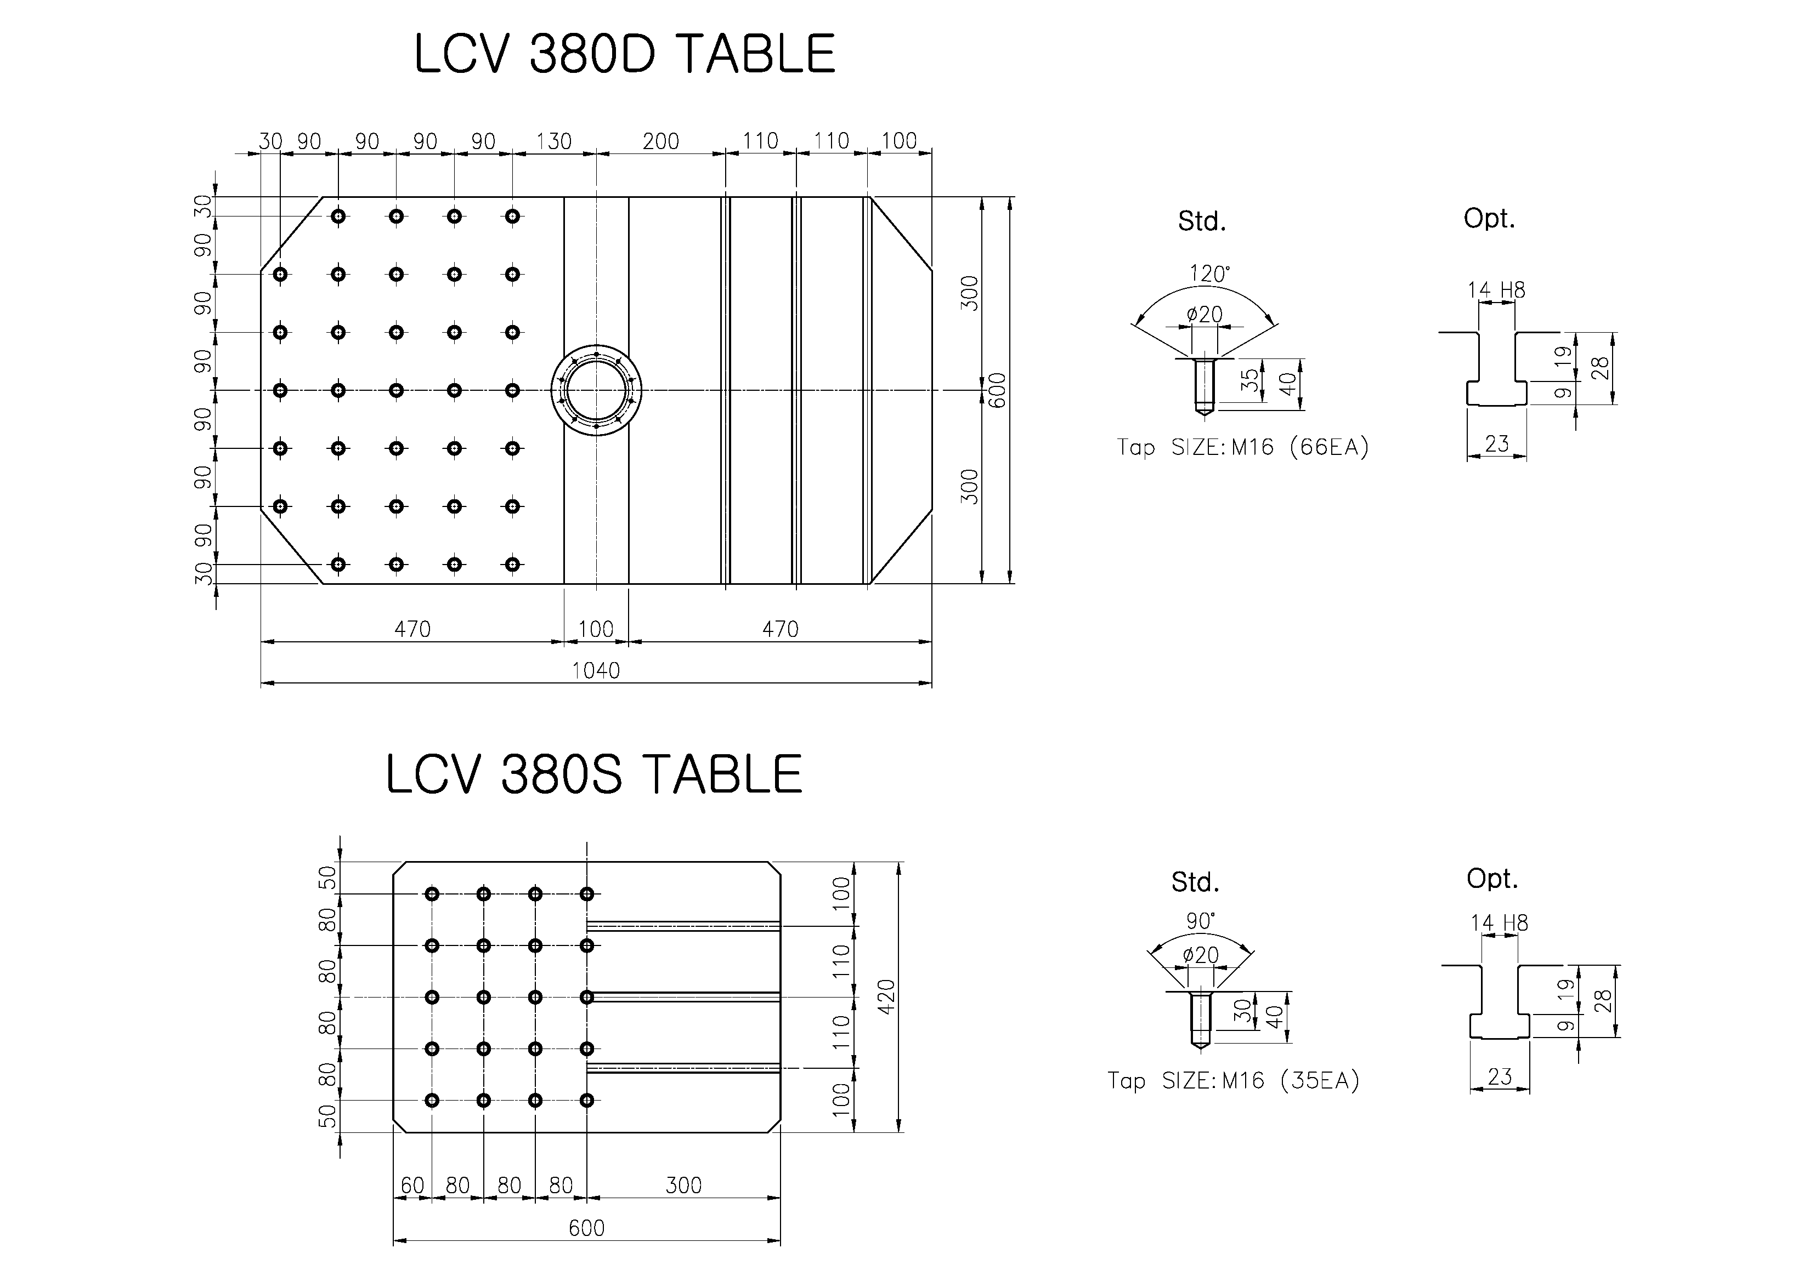
LOADING CAPACITY DIMENSION

LCV 380D
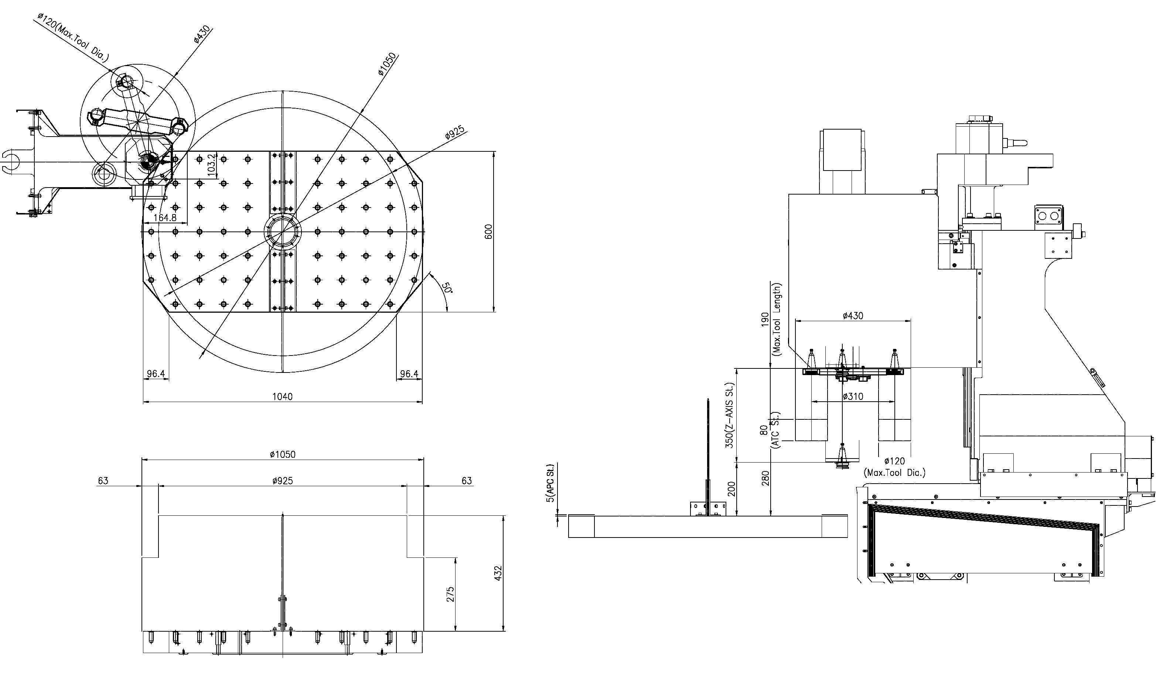

LCV 380S

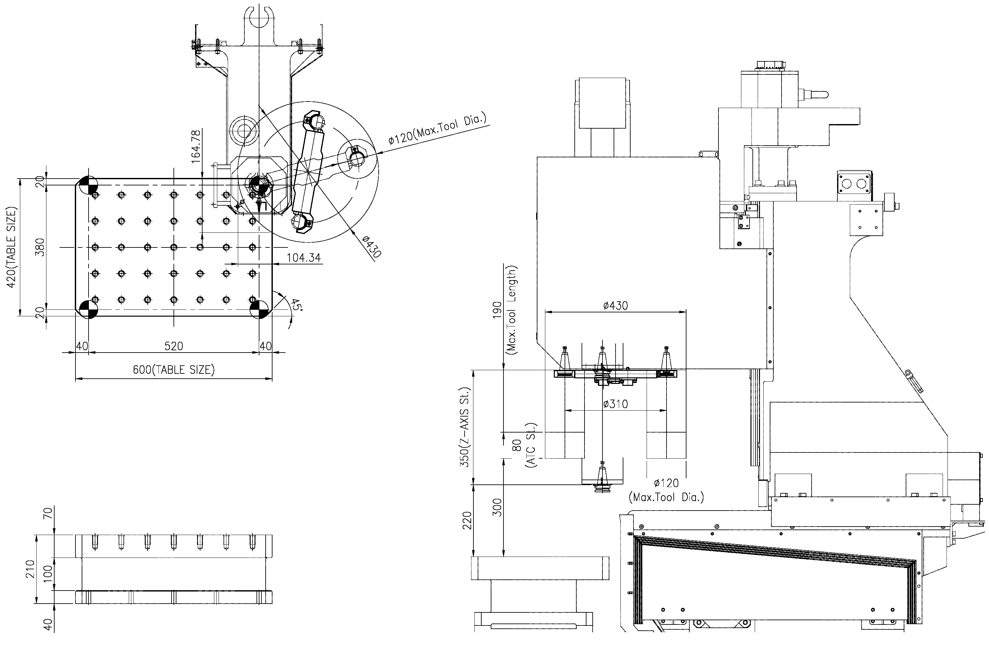

HYDRAULIC POWER UNIT(LCV 380D Only)
- Motor power 1.5 kW
- Discharge setting pressure 60 kgf/㎠
- Max. discharge flow rate 14 L/min (60Hz)
- Tank capacity 11 L
- Main power 1.5kWx200V/380x4Px50/60Hz

LUBRICATION
- Pump unit AMZ-III-100S-30LP (LUBE)
- Motor 18W AC100V x 60Hz
- Discharge flow rate 0.09 / 0.11 L/min
- Discharge pressure 15 kgf/㎠
- Tank capacity 3 Liters

PNEUMATIC
- F.R.L unit AW40-04DG (SMC)
- operating Pressure 0.5~0.6 Mpa
- Air Lubricator oil ISO VG-32

COOLANT AND CHIP PAN
- Type Removable / Independent
- Coolant capacity 327 Liter
- Pump motor 400 W
- Discharge & Pressure 200 L/min
0.5 kg/cm² 60Hz

MACHINE LAY-OUT(LCV 380D)
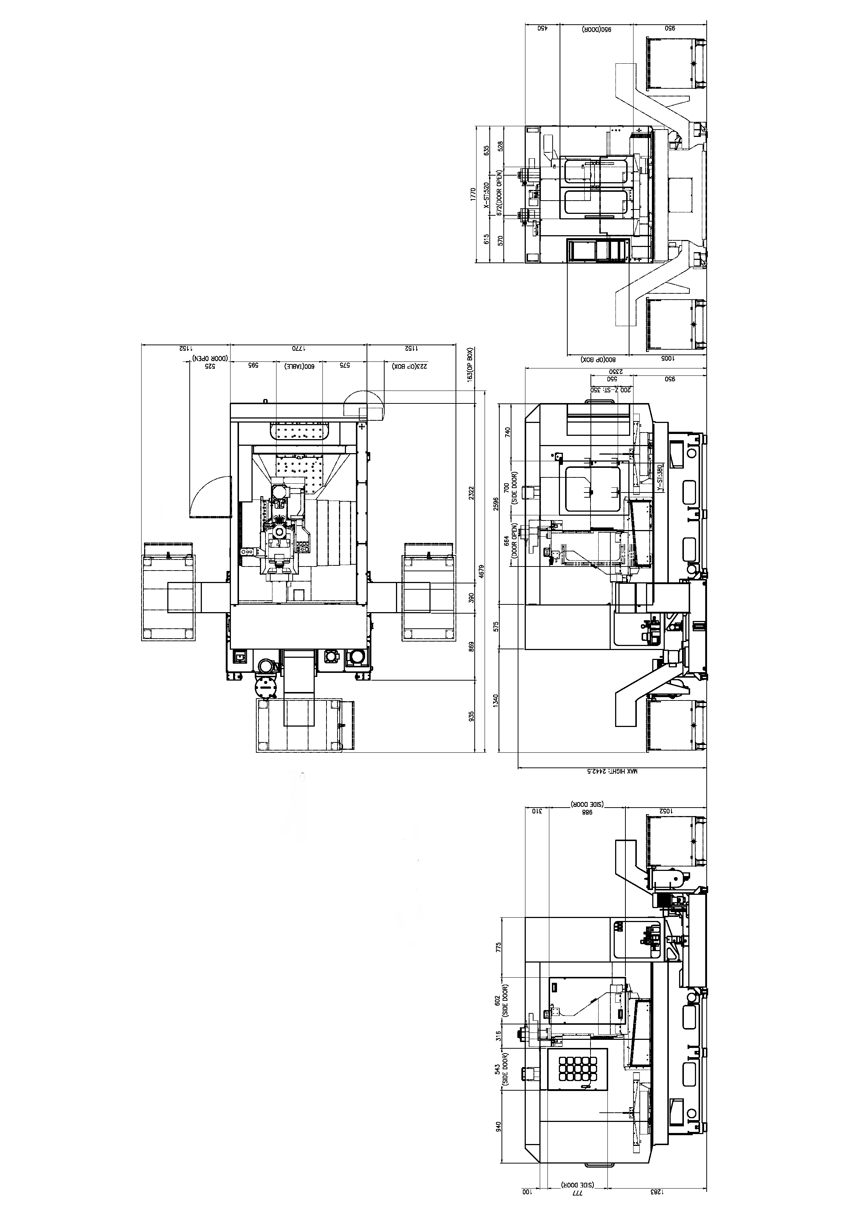

MACHINE LAY-OUT(LCV 380S)
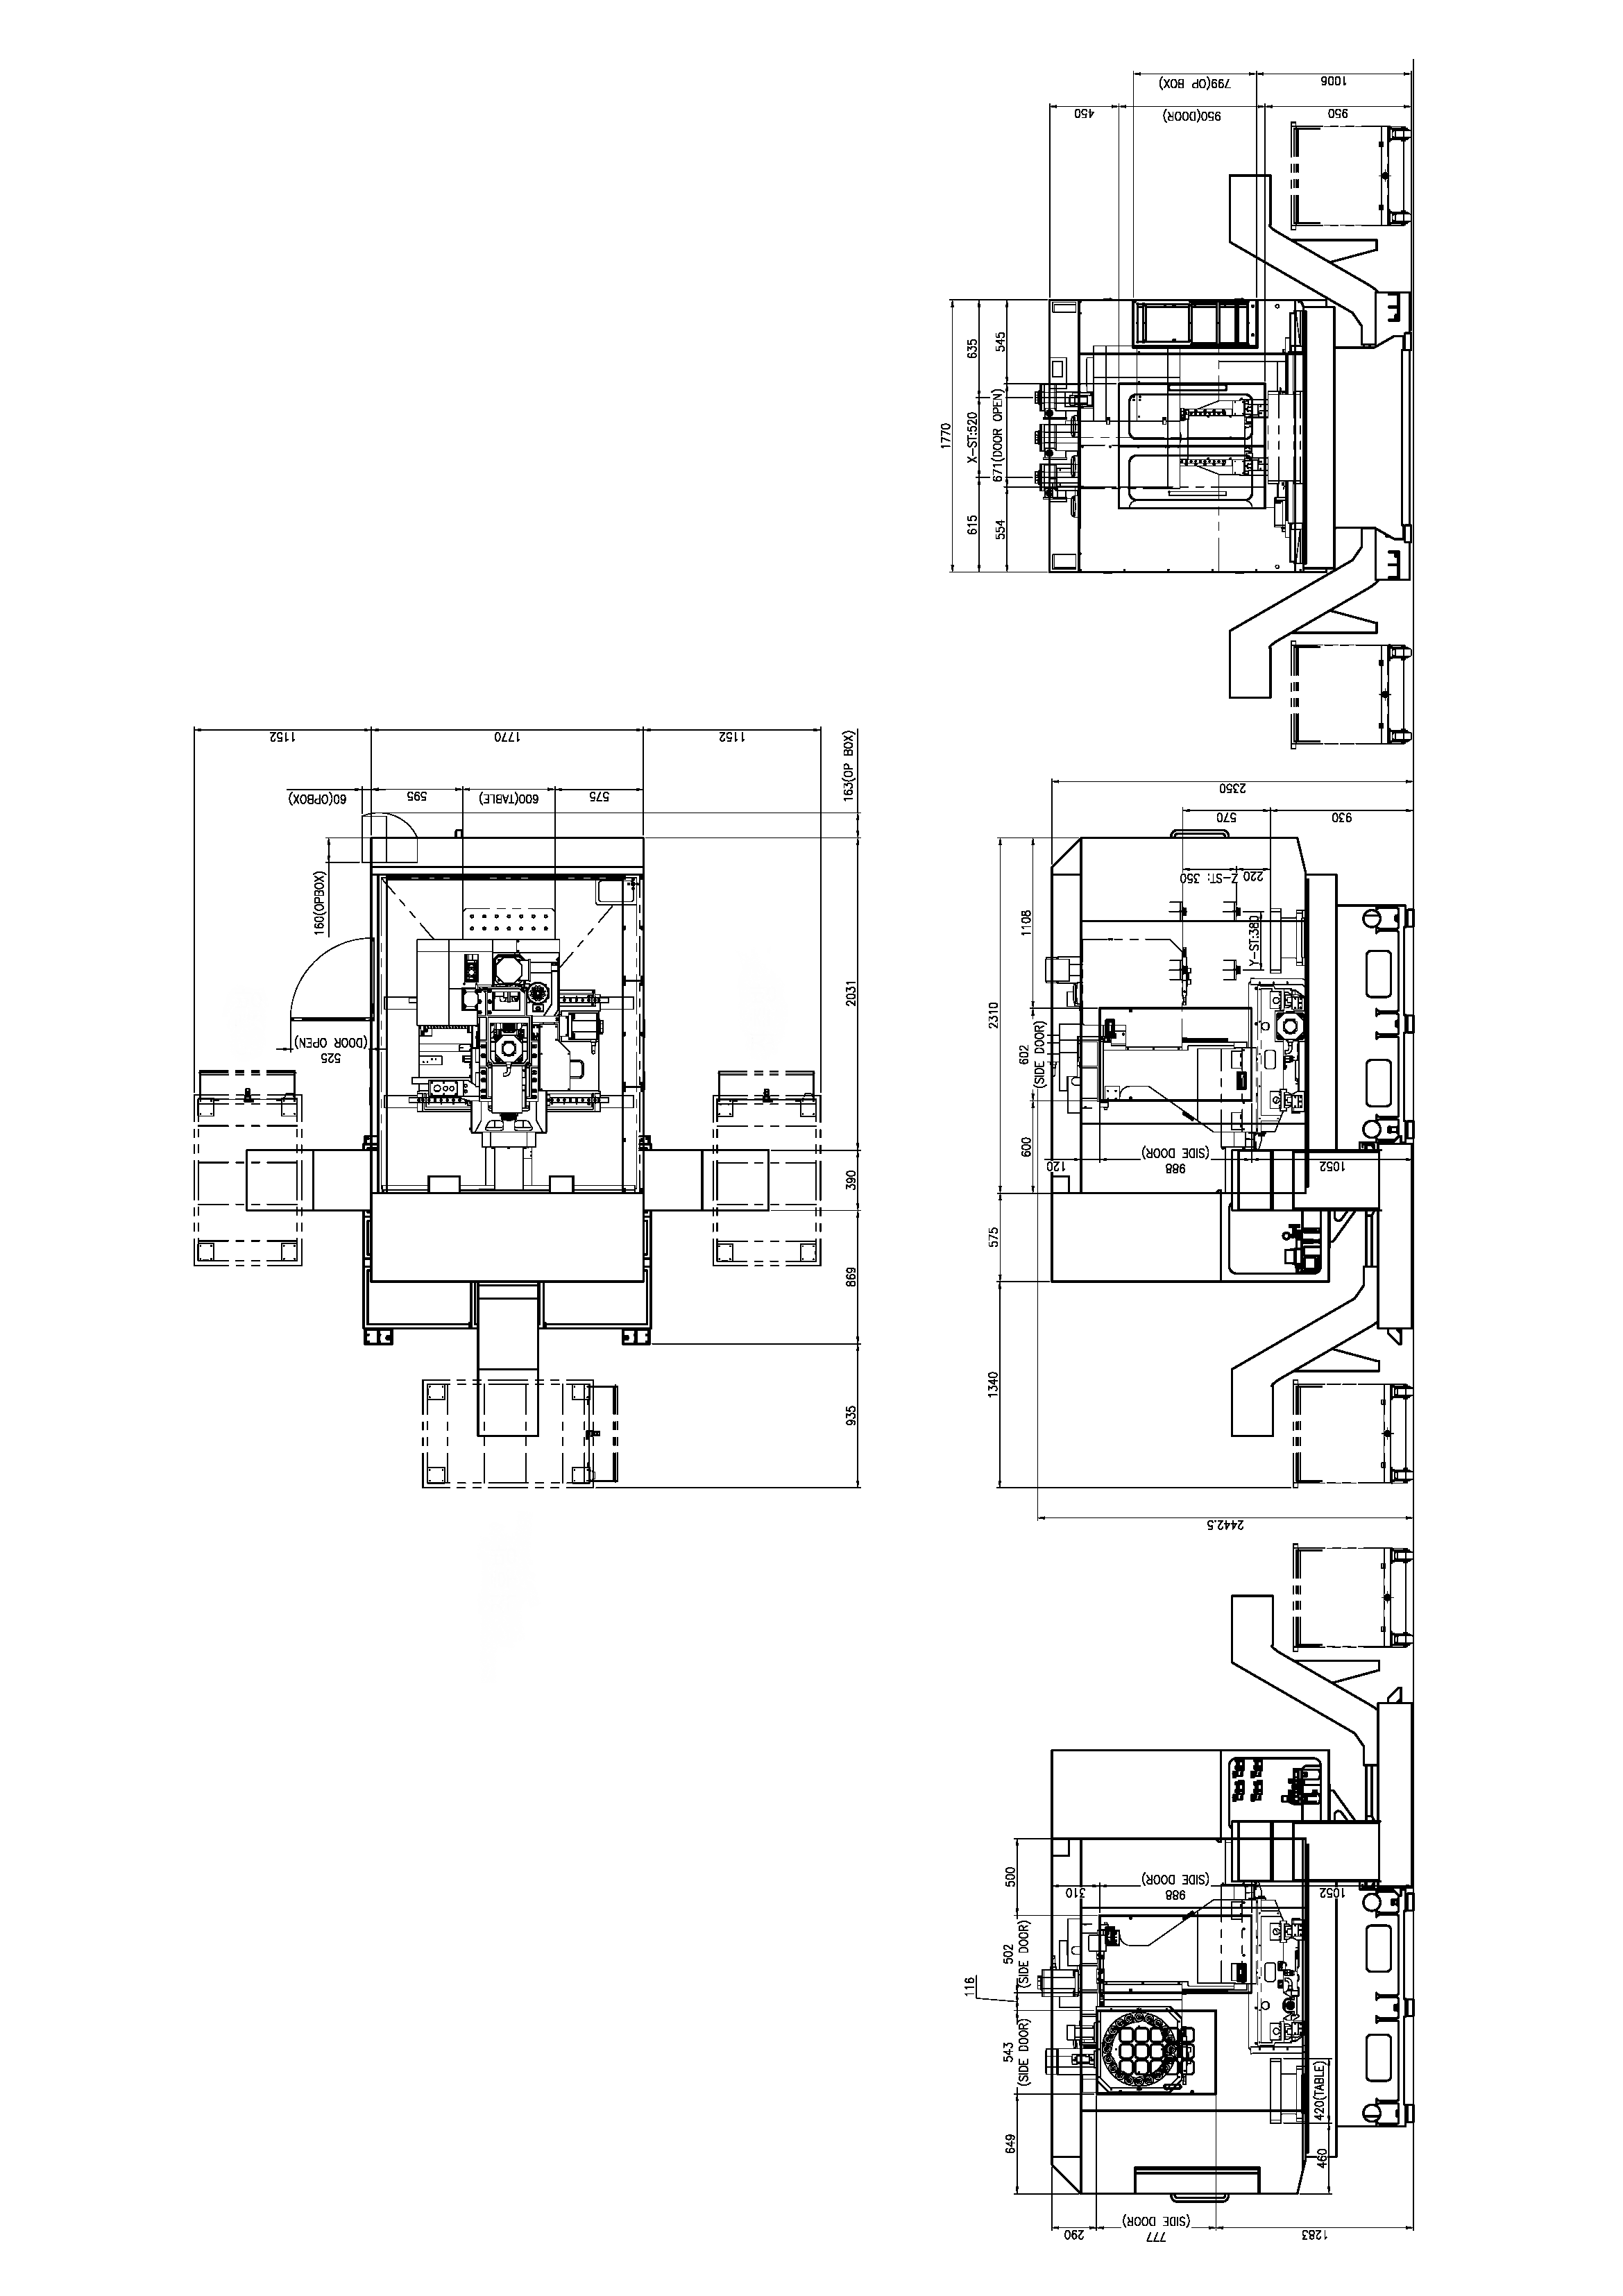

MACHINE SPECIFICATIONS

TRAVEL
X axis travel 520 mm
Y axis travel 380 mm
Z axis travel 350 mm
Distance from table top to spindle nose 200~550(*570) mm

TABLE
Table size 2-600x520(*600x420) mm
Loading capacity 2x200(*Fixed table) kgf
Table surface configuration 2x33-M16x90x90(*35-M16x80x80)

SPINDLE
Spindle speed 12,000 rpm
Transmission Direct drive
Bearing inner Diameter ø50 mm
Max. Torque (30min/cont.) 3.6/2.4 kgf.m [35.3/23.5 N.m]

AUTO TOOL CHANGER
Tool Shank BT30
Pull stud type MAS P30T-1 (45° type)
Maximum tool Diameter [Adjacent empty] 60 mm [120 mm]
Maximum tool length 200 mm
Maximum tool weight 3 kgf
Tool changing method Double arm swing
Tool selection method Memory random
Tool changing time(T-T) 0.85 sec
Magazine capacity 20 ea

FEED RATE
Rapid traverse(X/Y/Z) 20/20/16 m/min
Cutting feed rate 1~10,000mm

MOTORS
Spindle drive motor(30min/Cont.) 5.5/3.7kw
Feed motor (X/Y/Z) 3kw/3kw/3kw
Coolant pump motor 400 W
Lubricant pump motor 18W

MACHINE SIZE
Floor space (LxW) 3,476x1,898(*3,190x1,870) mm
Machine height 2,443 mm
Mass of machine 4,500(*4,000) kgf
Total power capacity 30 kVA

CNC System Fanuc 0i-MC

STANDARD EQUIPMENT

- 8.4” TFT LCD Color Monitor
- Machine Work Light : halogen Lamp
- Coolant System: Tank capacity: 327 Liters, 400 W pump
- Full Splash Guard
- Hydraulic Unit(LCV 380D Only)
- Lubrication System
- Machine installation part
- Manuals: (Instruction, Operating, Part List, Electric circuit diagrams)

CONTROL SPECIFICATIONS

- TYPE OF CONTROL
- 32-bit multiprocessor continuous-path control

- HARDWARE COMPONENTS
- 8.4” Color TFT LCD screen
- Flash memory card interface
- RS 232C interface

- SCREEN DISPLAY
- Window oriented operator interface
- Display of current block during program execution
- Screen texts: English (other languages: Option)
- Actual cutting / spindle speed display
- Alarm display and Alarm history display
- Clock (function) display

- OPERATION
- Program protection on machine control panel
- 640M part programming storage
- Number of Registered Programs: 400
- Built-in Run Hour / Parts Counter Display
- Tool life management
- Automatic tool measurement and compensation (with tool eye)
- Background editing
- Linear and circular interpolation
- Help function

- MODES
- AUTOMATIC
- Control of AUTOMATIC mode by:
- Feed hold and spindle stop
- Skip block
- Single block
- Dry run feedrate
- JOG (setup)
- MDI (manual data input)

- MACHINE CONFIGURATION FOR AXES
- Inch or metric programming
- Switchover between metric and inch for input and offsets, display, programmed traverse path
- Feed-rate and rapid traverse: minimum input feed-rate in mm/min=0.001(inches/min = 0.0001) .
- Revolution feed-rate: minimum input federate in mm/rev=0.001( inches/rev = 0.0001)

- MACHINE SPINDLE CONFIGURATIONS
- Constant cutting speed, cutting feed-rate clamp
- 1 position Spindle Orientation

- OVERRIDES , OFFSETS AND COMPENSATIONS
- Feed-rate override 0% to 200%
- Rapid traverse override 0%, 25%, 50%, 100%
- Spindle speed override 50% to 120%
- Tool Offsets(400pairs)
- Backlash compensation
- Cutter compensation C

- CNC PROGRAMMING
- Mirror image by each axis
- Stored stroke check 1, 2nd reference position return
- Work coordinate system (G52 ~ G59)
- Skip function, optional block skip / 1 ea
- Sub-program call (4 level)
- Searching function: Program no., Sequence no., and external work no.
- Absolute and incremental programming
- Dwell time can be programmed in seconds or revolutions
- Single block by each axis, dry run
- Program restart
- Rigid tapping
- Number of registered program(400)
- Parts program storage length(640M)
- Custom macro B
- Optional block skip 9

- SAFETY AND DIAGNOSTIC FUNCTIONS
- Safety routines permanently active for measuring circuits, over temperature, battery, voltage, memory, limit switches, fan monitoring
- Self diagnostics
- Contour monitoring
- Spindle monitoring

INVESTMENT

BASE PRICE: $__________ FOB PORT

SAMSUNG LCV 80 / 66 with Fanuc 0i-MD control

TERMS OF PAYMENT:

OPTIONAL EQUIPMENT

- Lift up chip conveyor & Bucket
- Gun coolant
- Air blow
- Through spindle coolant
- Oil skimmer
- Auto tool length measurement unit
- Additional 1 axis,2Axis system
- 3-MPG
- Data server
- AI contour control
- Air gun
- Side oil hole
- Flood coolant

STANDARD TERMS AND CONDITIONS

Warranty
The machine is warranted against defects in parts, material and workmanship for a period of twelve months after the date of installation. The control, servomotors and main spindle motor are warranted against defects in parts, material and workmanship for a period of twenty-four months after the date of installation.

Installation
Installation of the machine/control system is supervised by SAMSUNG factory trained servicemen without charge to customer. Initial training on machine/control operation and programming will also be done at the time of the machine installation. Additional training in N/C programming will be available on a scheduled basis.

Delivery
Free on Board, Port of Entry, Duty paid, approximately two to four months upon receipt of firm purchase order with down payment.

Payment Terms
( )

Thank you for the opportunity to quote your machining needs with the SAMSUNG LCV-650 Machining Center.

After an examination of this quotation, should you have any questions, or desire additional information, please do not hesitate to contact us.
Sincerely,

