**SAMSUNG**

***LCV-30A/B***

**VERTICAL MACHINING CENTER**

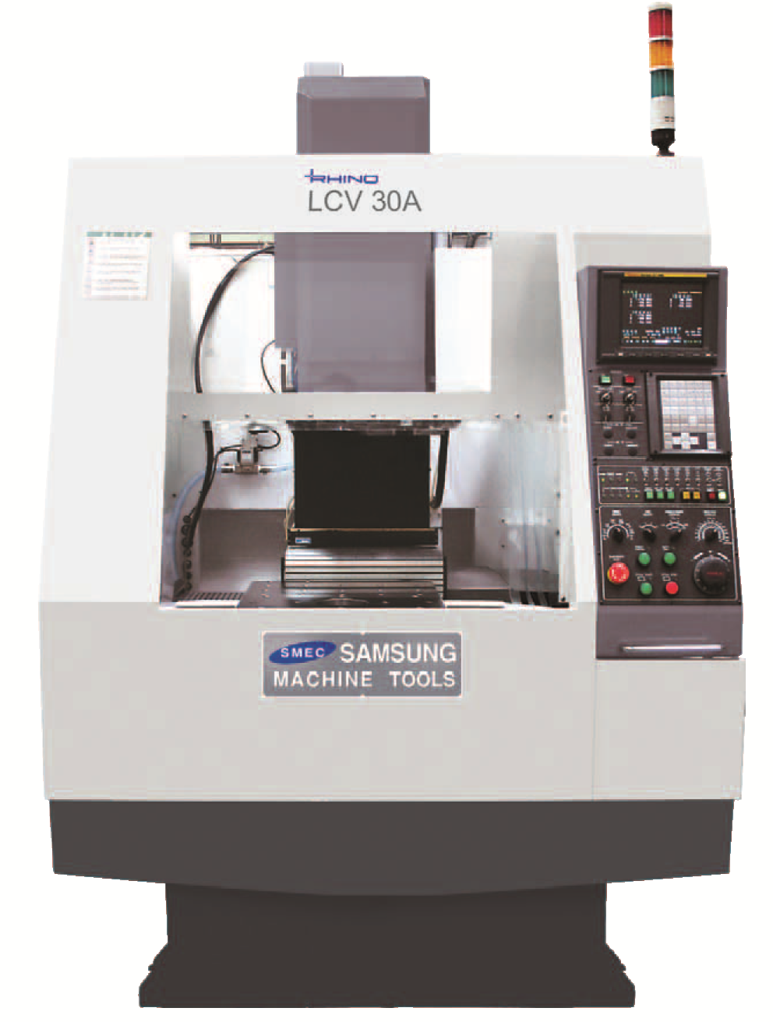

**MACHINE CONSTRUCTION / FEATURES**

**MAIN FRAME**

* ***Lowering center of gravity design and secured wide bed guide way***
* ***Hardened and ground box type slideway***
* ***High rigid triangular rib body structure minimize vibration and deformation under heavy machining***

**SPINDLE HEAD**

|  |  |  |  |
| --- | --- | --- | --- |
| **Spindle Taper** | **Unit** | **BT 30** | |
| **Spindle Drive Motor** |  | αiI 3/10000 | αiI 2/20000 |
| **Spindle speed** | rpm | 10,000 | 15,000 |
| **Spindle Drive Method** | type | Direct Drive | Directly connected |
| **Motor power** | kW | 5.5[30min]/3.7 | 3.7[30min]/2.2 |
| **Max. Torque**  **(S3 25%/Short/ Cont)** |  | 35.3/23.5 | 11.8/6.9 |
| **Spindle Bearings** | Front | 7010CD/P4AQBCA | 7020CD/P4AQBCA |
| **Spindle BRG lubrication** |  | Grease | Grease |
| **Spindle cooling**  **(Oil Cooling)** | - |  |  |
| **Tool clamping Method** | - | Disk  Spring(MUBEA) | Disk  Spring(MUBEA) |
| **Tool clamping/unclamping force** | N | 1,486.8 / 1,987.9 | 1,486.8 / 1,987.9 |
| **Tool unclamping method** | kgf/㎠ | Pneumatic 5 | Pneumatic 5 |

**SPINDLE POWER-TORQUE DIAGRAM**

|  |
| --- |
| **BT30 10000 RPM** |
| Power (kW)  Torque (N.m)  RPM |
| **BT30 15000 RPM** |
| RPM  Torque (N.m)  Power (kW) |

***POWERFUL Fanuc α Series***

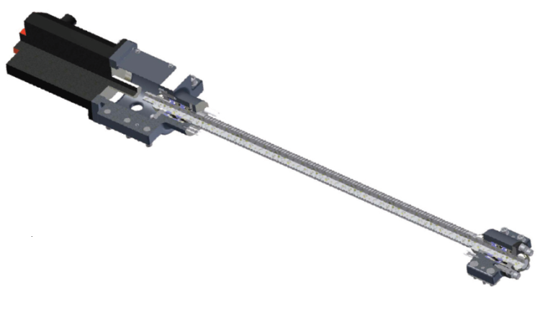

***SERVO DRIVE SYSTEM***

Both side fixed type supporting system (2x4rows thrust angular ball bearings)

Pre-tensioned Double anchor method ball screw supporting system

|  |  |  |  |  |
| --- | --- | --- | --- | --- |
| **Items** | | **X-axis** | **Y-axis** | **Z-axis** |
| **Travel**  **Rapid Traverse** | | 500mm  48m/min | 320mm  48m/min | 330mm  48m/min |
| **Ball screw** | Diameter x Lead | Ø32mm x 16mm | Ø32mm x 16mm | Ø32mm x 16mm |
| Spec.(HIWIN) | R32-16K5-FSC-692-838-0.008 | R32-16K5-FSC-520-693-0.008 | R32-16K5-FSC-523-705-0.008 |
| **Drive motor**  **(FANUC)** | Servo Motor Type  Rated power | α 8/3000i  1.6kW | α 8/3000i  1.6kW | α 8B/3000i  1.6kW |
| **Feedback system** | Absolute | | | |
| **Guide way** | Slide Ways  Slide Way Span  Slide way Width  Safety Device | L.M guide  450mm  34mm  Soft OT, Mech. Stopper | L.M guide  300mm  34mm  Soft OT, Mech. Stopper | L.M guide  350mm  34mm  Soft OT, Mech. Stopper |
| Spec.(HIWIN) | HGW35HAE1R1010ZBP II | HGW35HAE2R800ZBP II | HGH30HAE2R790ZBP II |
| **Accuracy** | Positioning  Repeatability | ±0.003  ±0.002 | | |

***AUTOMATIC TOOL CHANGER***

***/ MAGAZINE***

* **Tool Shank** < BT 30 >

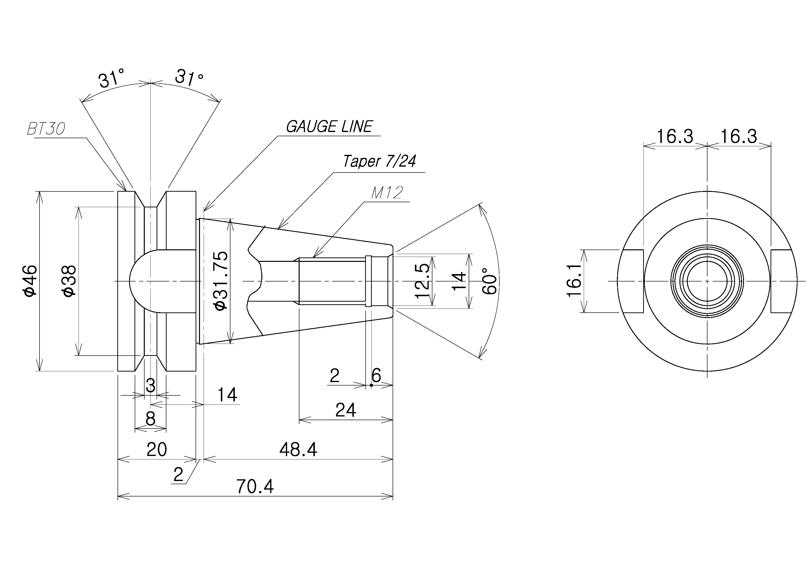

* **Pull stud type** < MAS P30T-1 > - 45° type

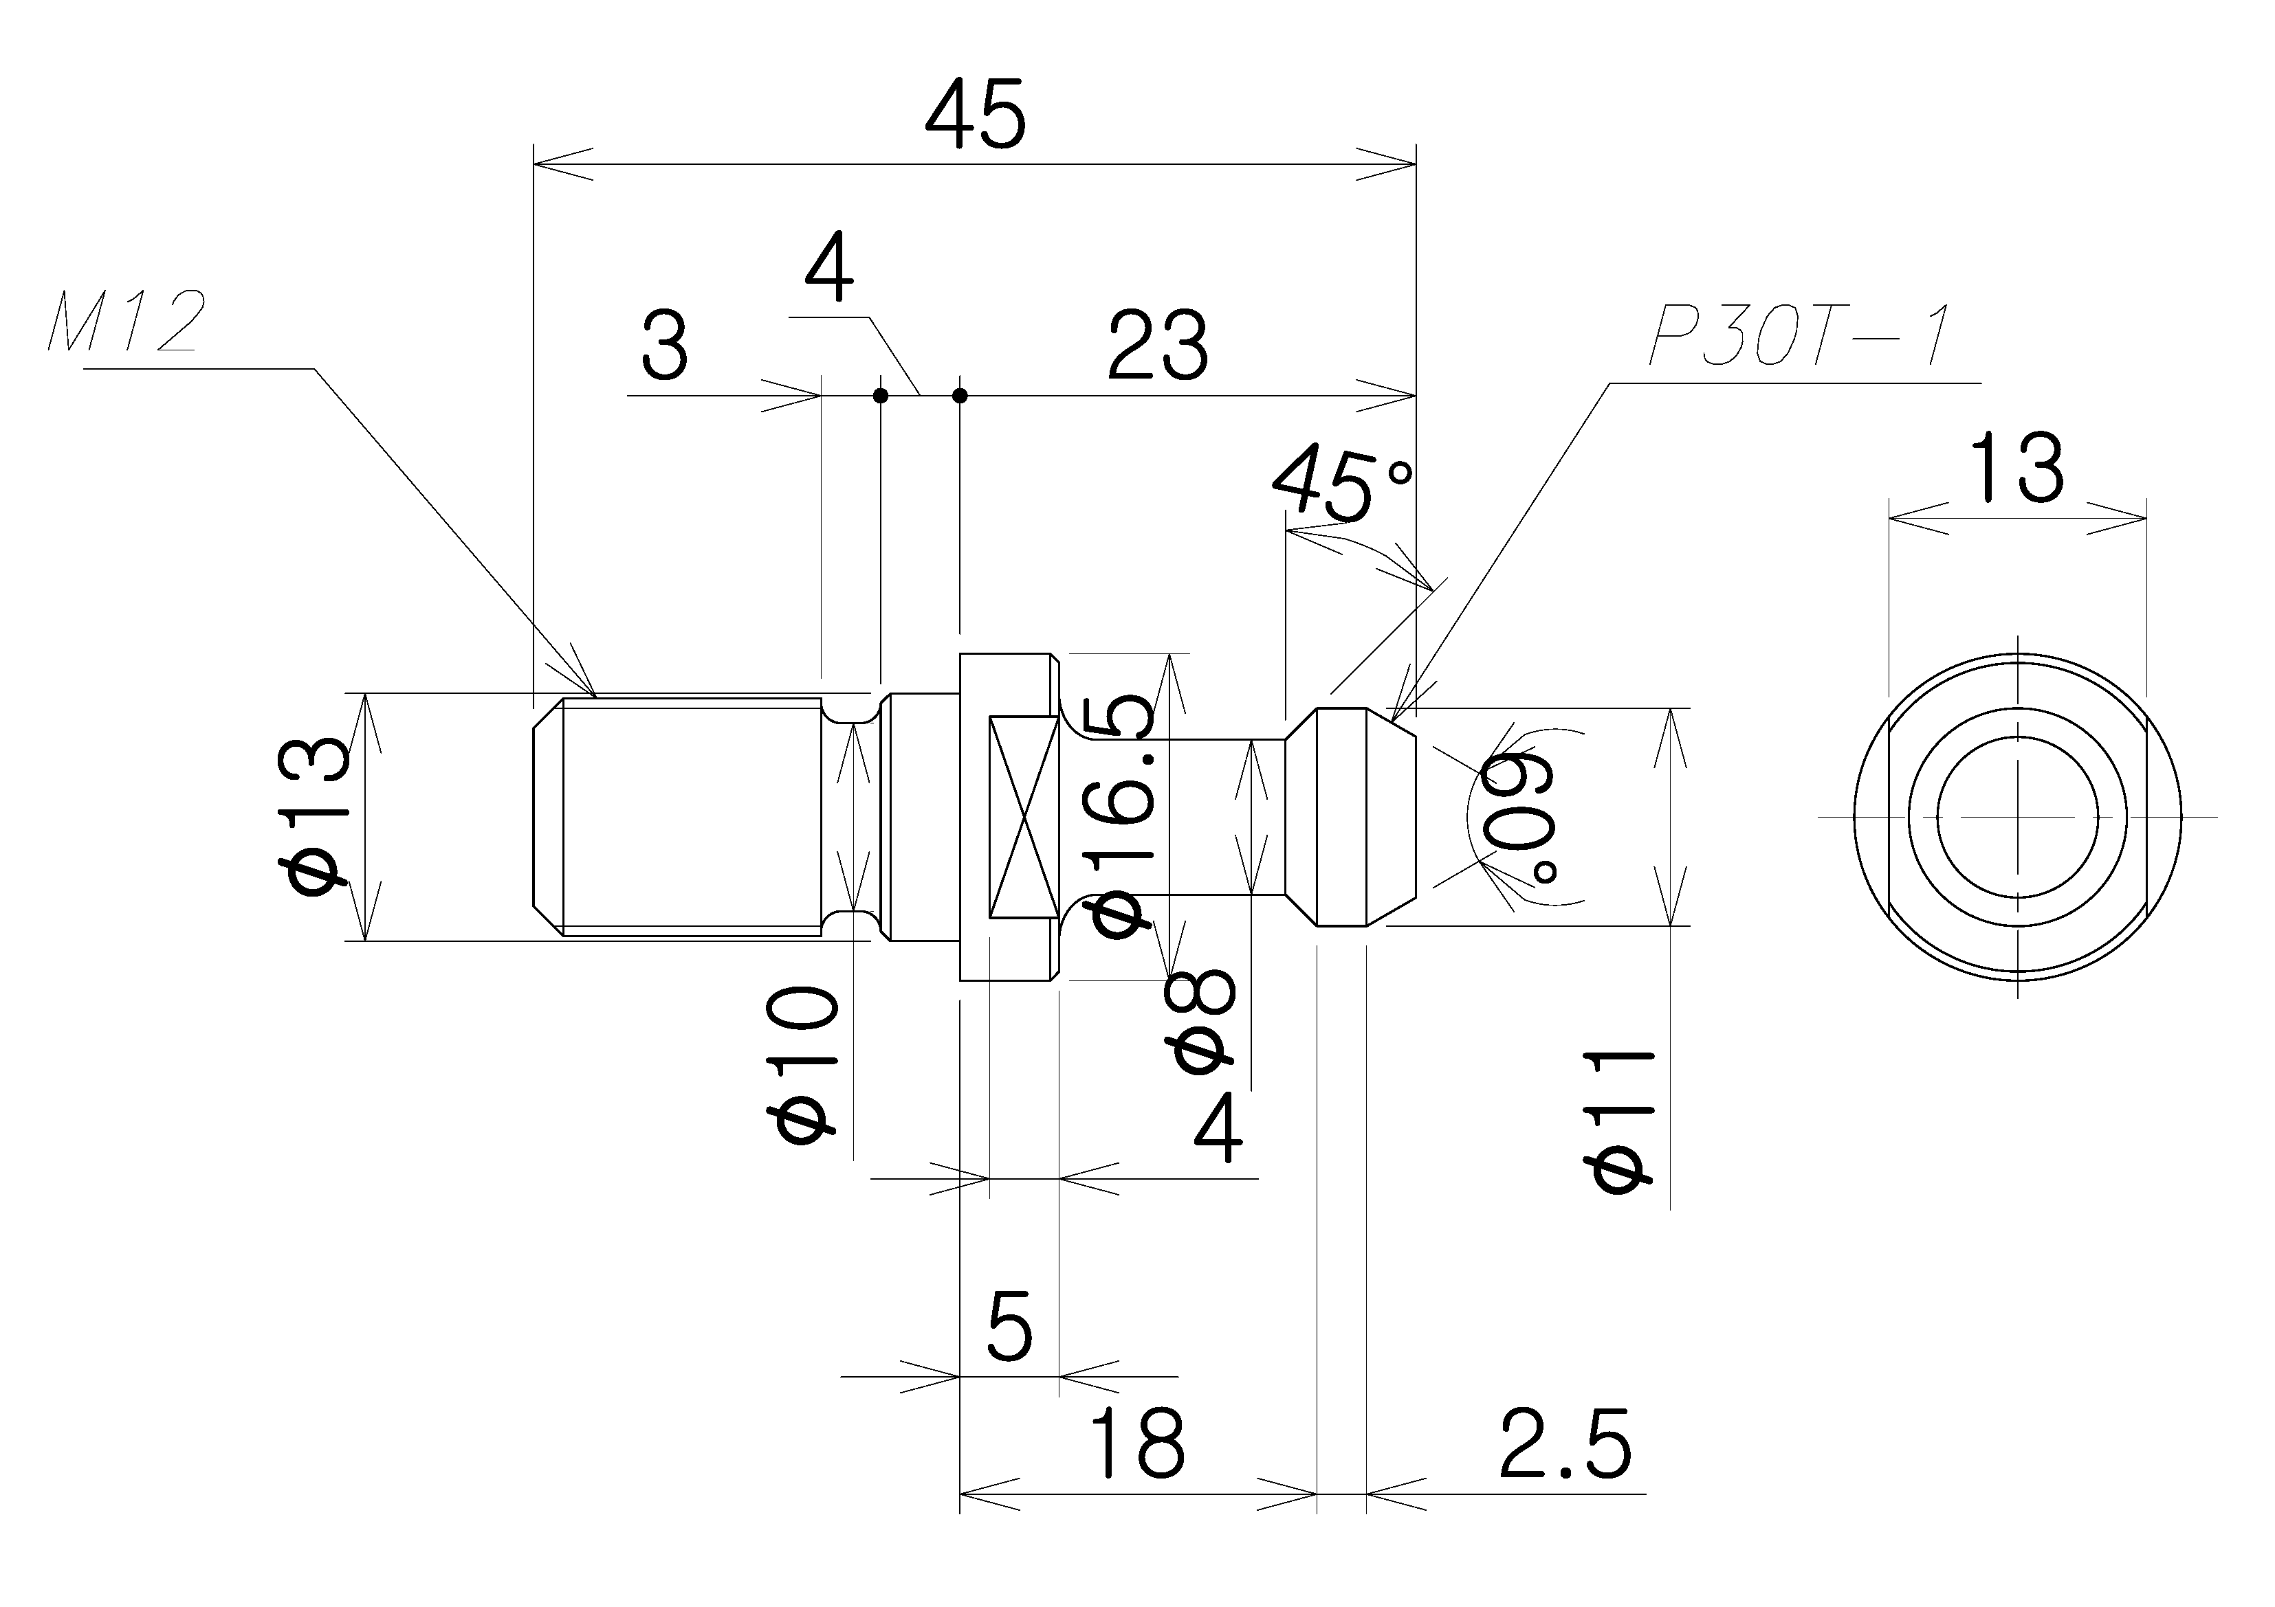

* **Maximum tool Diameter** 75 mm
* **Maximum tool Diameter** 80 mm

**[Adjacent empty]**

* **Maximum tool length** 200 mm
* **Maximum tool weight** 3 kgf
* **Tool changing method** Double arm swing
* **Tool selection method** Memory random
* **Tool changing time(T-T)** 0.7 sec
* **Magazine capacity** 16 ea

***TABLE***

* **Table size**  500mmx1,000mm(*660mmx400mm)
* **Loading capacity** 150x150kgf(*Fixed table)
* **Table surface Std.-Tap type**

40-M16x100x100

* **Table surface Opt.-T-slot**

**Width** 18 mm

**No. of slot** 8ea(*3ea)

**Distance between T-slot** 100(*110) mm

* **Distance from Floor to Table surface** 1,040**(\***1,019) mm

**< LCV-30A >**

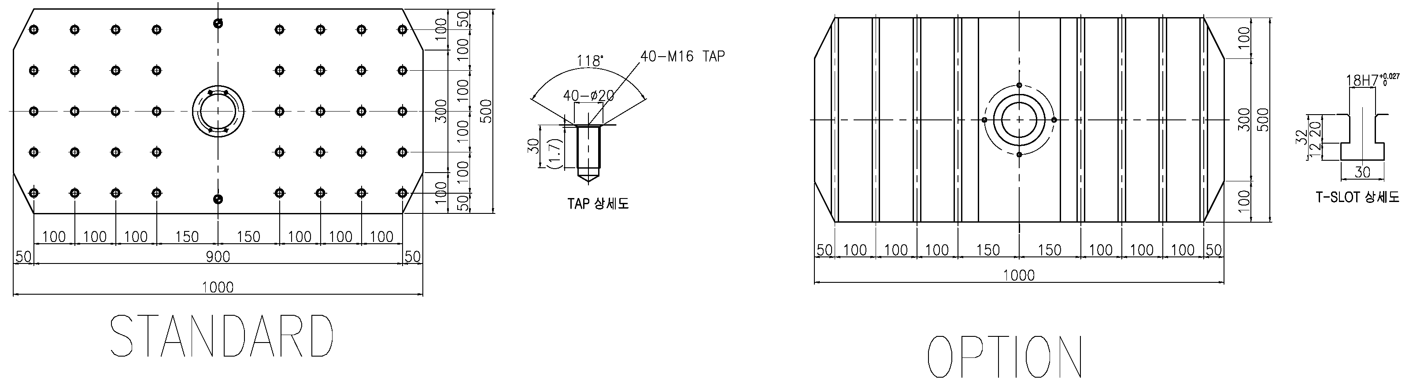

**<LCV-30B>**

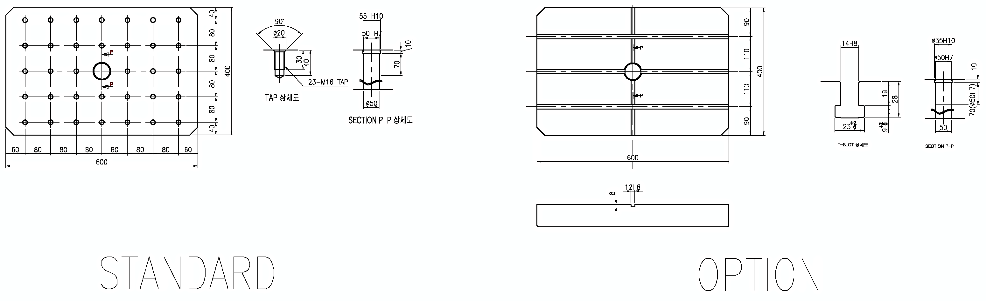

**LOADING CAPACITY DIMENSION**

LCV-30A

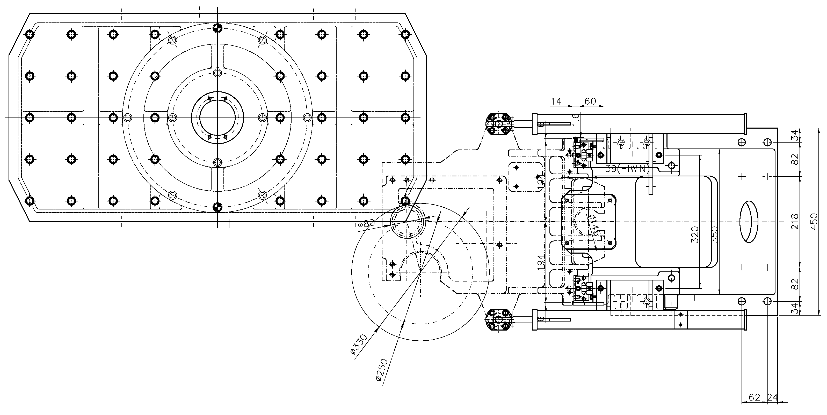

LCV-30B

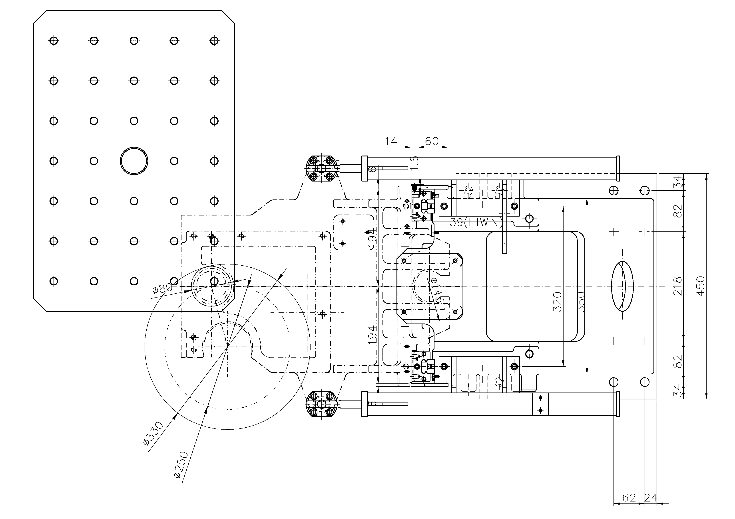

***HYDRAULIC POWER UNIT(LCV-30A Only)***

* **Motor power** 2.2 kW
* **Discharge setting pressure** 3.43 Mpa
* **Max. discharge flow rate** 28 L/min (60Hz)
* **Tank capacity** 24 L

***LUBRICATION***

* **Pump unit**  AMZ-III-100S-30LP (LUBE)
* **Motor** 18/19W AC100V x 50 / 60 Hz
* **Discharge flow rate**  0.09 / 0.11 L/min
* **Discharge pressure** 1.47 Mpa
* **Tank capacity** 3 Liters

***PNEUMATIC***

* **F.R.L unit**  AWL4000-G04BG-X (SMC)
* **operating Pressure**  0.5 Mpa
* **Air Lubricator oil**  ISO VG-32

***COOLANT AND CHIP PAN***

* **Type** Removable / Independent
* **Coolant capacity** 190 Liter
* **Pump motor** 1500 W
* **Discharge & Pressure** 400 L/min

***MACHINE LAY-OUT ( LCV-30A )***

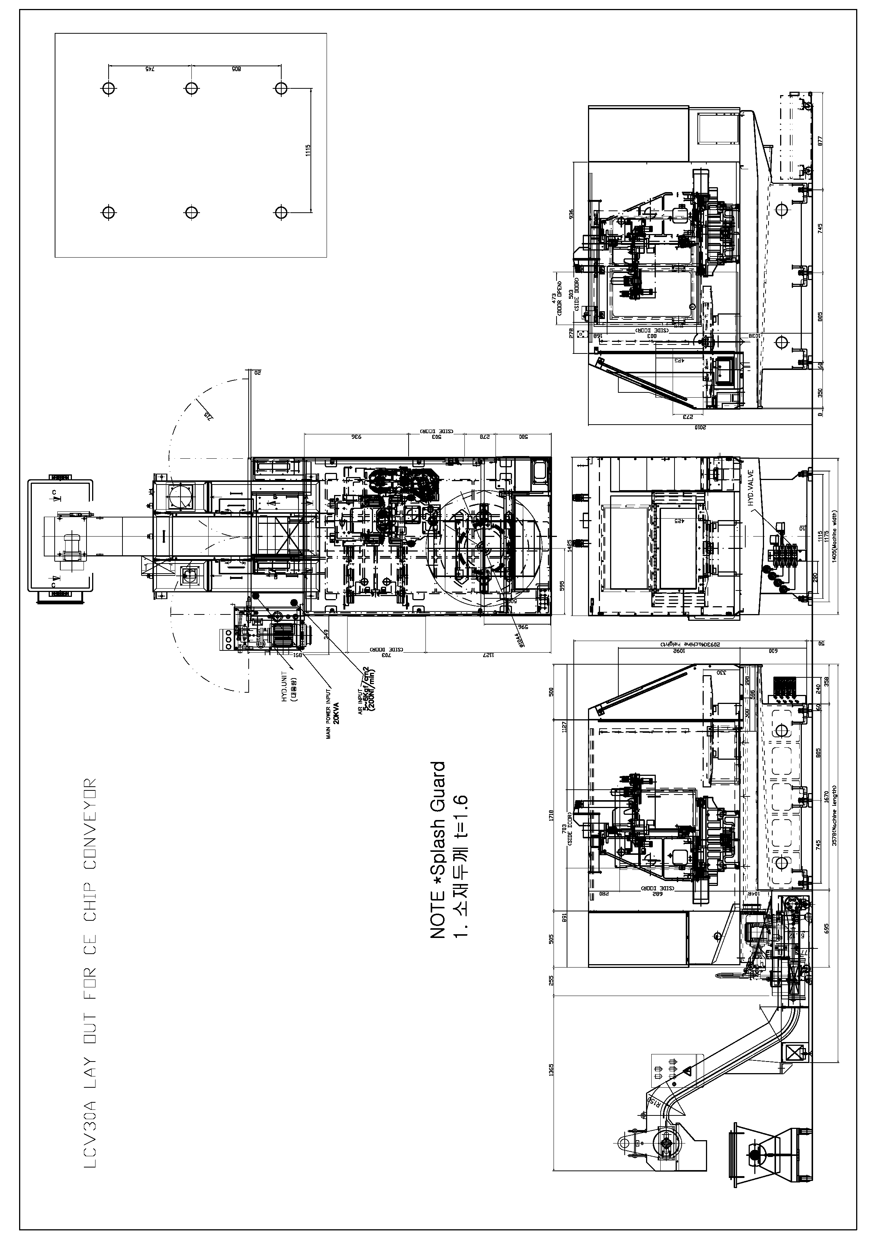

***MACHINE LAY-OUT (LCV-30B)***

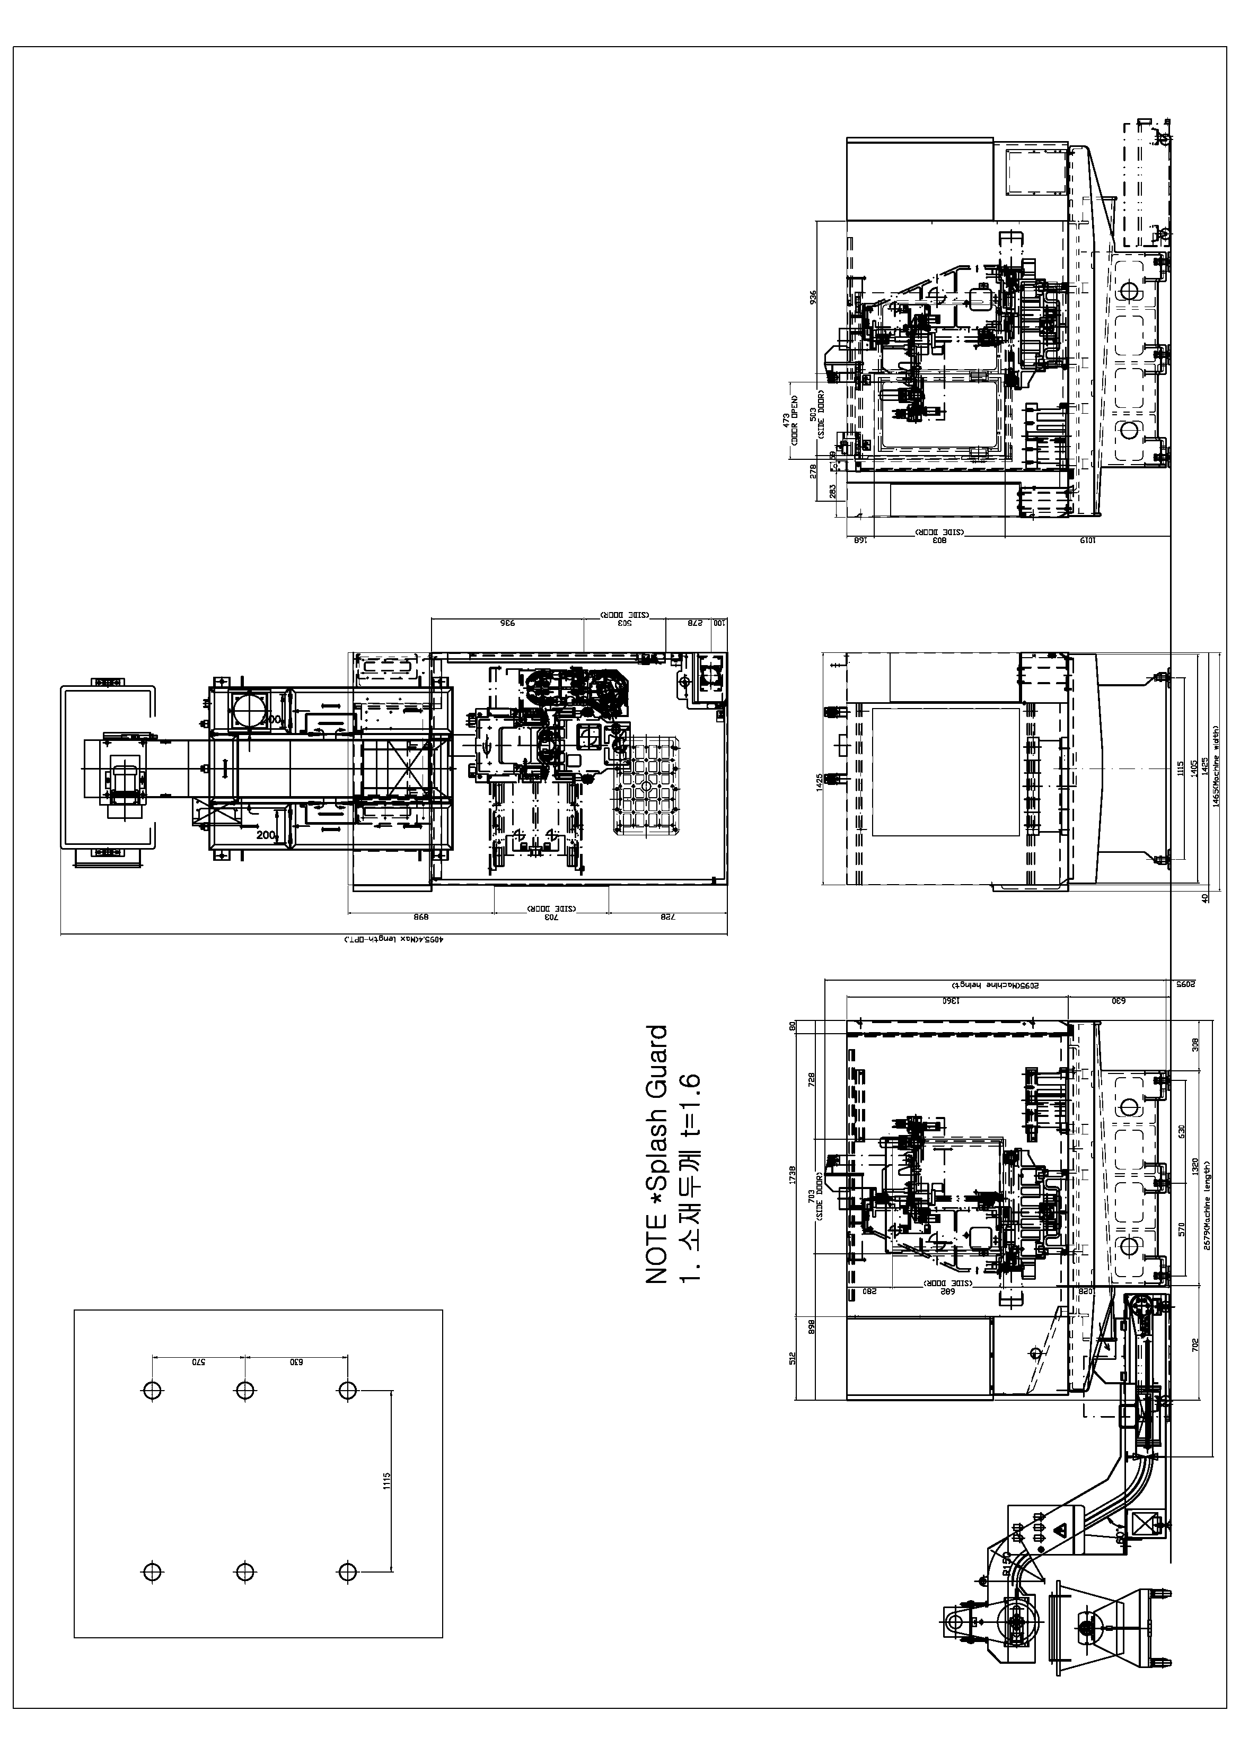

**MACHINE SPECIFICATIONS**

***TRAVEL***

X axis travel 500 mm

Y axis travel 320 mm

Z axis travel 330 mm

Distance from table top to spindle nose 150-480(*220-550) mm

Distance from column to spindle center 397mm

***TABLE***

Table size 500x1,000(*600x400) mm

Loading capacity 150 x 150kgf

Table surface configuration 40-M16x100x100(*32-M16x80x80)

***SPINDLE***

Spindle speed 10,000 rpm

Bearing inner Diameter Ô50 mm

Max. Torque (30min/cont.) 35.3/23.5

***AUTO TOOL CHANGER***

Tool Shank BT30

Pull stud type 45° type

Maximum tool Diameter [Adjacent empty] 75 mm [80 mm ]

Maximum tool length 200 mm

Maximum tool weight 3 kgf

Tool changing method Double arm swing

Tool selection method Memory random

Tool changing time(T-T) 0.7 sec

Magazine capacity 16 ea

***FEED RATE***

Rapid traverse(X/Y/Z) 48/48/48 m/min

Cutting feed rate 1~10,000mm

***ACCURACY***

Positioning ±0.003

Repeatability ±0.002

***MOTORS***

Spindle drive motor 5.5[30min]/3.7

Feed motor (X/Y/Z) 1.6kw/1.6kw/1.6kw

Coolant pump motor 1500 W

Lubricant pump motor 18 W

***MACHINE SIZE***

Floor space (LxW) 3,578x1,470(3,178x1,465) mm

Machine height 2,145(2,095) mm

Mass of machine 3,200(3,100) kgf

Total power capacity 20kVA

***CNC System*** Fanuc 0i-MD,

**STANDARD EQUIPMENT**

1. Full Splash guard

2. Coolant tank

3. Machine installation parts

4. Standard tool and tool box

5. Friction oil self-oiling system

6. Work lamp

7. Call light (3 color)

8. Rigid tapping

9. Spindle override

10. Bed flushing

**CONTROL SPECIFICATIONS**

|  | **Item** |  |
| --- | --- | --- |
| **Controlled axis** | Controlled axes | 3(X,Y,Z) |
| Max. simultaneously controlled axis | 4 |
| Least command increment | 0.001mm / 0.0001" |
| Stored stroke check 1 | O |
| Stored stroke check 2,3 | O |
| **Interpolation/Feed functions** | Linear interpolation | G01 |
| Circular interpolation | G02, G03 |
| Dwell | G04 |
| Cylindrical interpolation | G07.1 |
| Nano smoothing | OPT |
| Reference position return | G28 |
| Reference position return check | G27 |
| 2nd/3rd/4th reference position return | G30 |
| Rapid traverse rate override | F0, 25%, 50%, 100% |
| Feedrate override | 0~200% |
| Jog Override | O |
| AI contour control I | - |
| AI contour control II | O |
| Pulse handle feed | X1, X10, X100 |
| Feedrate per minute | G94 |
| Feedrate per revolution | G95 |
| **Spindle function** | Spindle orientation | O |
| Rigid tapping | O |
| Spindle override | 50 ~ 150% |
| **Tool functions** | Tool number command | T2-Digt |
| Tool nose radius compensation | G40 ~ G42 |
| Tool offset pairs | 400 |
| Tool geometry/wear offset | O |
| Tool life management | O |
| Tool path graphic display | O |
| Automatic tool length measurement | O |
| **Program input, Editing operation** | Absolute/incremental programming | O |
| Multiple repetitive cycle | G70 ~ G76 |
| Canned cycles | G90, G92, G94 |
| Decimal point programming | O |
| Inch/metric conversion | G20 / G21 |
| Program restart | O |
| Sub program call | O |
| Retraction for rigid tapping | O |
| Max. programmable dimension | ±99999.999mm/±9999.9999" |
| M function | M3 digit |
| Custom macro | O |
| Canned cycle for drilling | O |
| Direct drawing dimension programming | O |
| Programmable data input | G10 |
| Tape code | ISO / EIA |
| Single Block | O |
| Dry Run | O |
| Optional block skip | O |
| Workpiece coordinate system | G52 ~ G59 |
| Part program storage size | 512Kbyte(1280m) |
| Number of registerable programs | 400EA |
| **Interface function, Data input/output** | Embedded ethemet | O |
| I/O Interface | O |
| Fast data server | O |
| Memory card input/output | O |
| USB memory input/output | O |
| **Setting and display** | Alarm & Operator histor display | O |
| Run hour and parts count display | O |
| Display spindle & servo overload | O |
| Self-diagnosis function | O |
| Extended part program editing | O |
| Display screen | 8.4"/10.4" color |
| External message | O |
| Multi-language display | O |

**INVESTMENT**

**BASE PRICE: $__________ FOB PORT**

**SAMSUNG LCV30A/B with Fanuc 0i-MD control**

TERMS OF PAY MENT:

**OPTIONAL EQUIPMENT**

1. Chip conveyor (Side, Rear : Lift up type, Scraper type, Mesh drum type)

2. Air blow

3. Gun coolant

4. Auto tool length measuring device

7. Addition 1-axis, 2-axis device

8. 3MPG

9. Work Counter

10. Integrating meter

11. Data server

12. AICC

13. Oil skimmer

14. Auto power cut off

**STANDARD TERMS AND CONDITIONS**

***Warranty***

The machine is warranted against defects in parts, material and workmanship for a period of twelve months after the date of installation. The control, servomotors and main spindle motor are warranted against defects in parts, material and workmanship for a period of twenty-four months after the date of installation.

***Installation***

Installation of the machine/control system is supervised by SAMSUNG factory trained servicemen without charge to customer. Initial training on machine/control operation and programming will also be done at the time of the machine installation. Additional training in N/C programming will be available on a scheduled basis.

***Delivery***

Free on Board, Port of Entry, Duty paid, approximately two to four months upon receipt of firm purchase order with down payment.

***Payment Terms***

**( )**

Thank you for the opportunity to quote your machining needs with the SAMSUNG LCV-650 Machining Center.

After an examination of this quotation, should you have any questions, or desire additional information, please do not hesitate to contact us.

Sincerely,